DATA FLOW DIAGRAM
Date | 29 September 2026
Team ID | XXXXXX
Project Name | PocketSmart AI: Your Smart Budget & Recommendation Assistant
Maximum Marks | 2 Marks

Data Flow Diagram
The following DFD shows how data moves through PocketSmart AI between the user, the main recommendation process, Gemini AI, external product/service platforms, and the system's data stores.
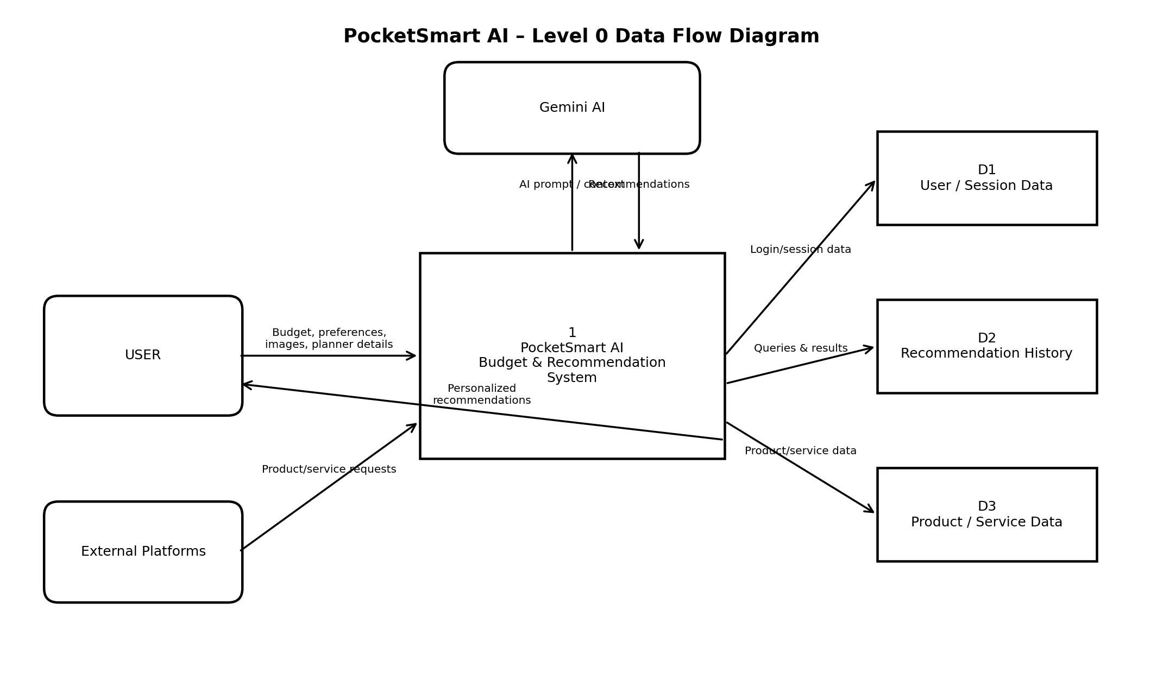
DFD Components
Component | Type | Purpose
User | External Entity | Provides budget, preferences, planner details and optional outfit images.
PocketSmart AI | Process | Processes planner inputs and generates personalized budget-aware recommendations.
Gemini AI | External Entity / AI Service | Analyzes text and image context and generates recommendation insights.
User / Session Data | Data Store | Stores user/session information used for personalization.
Recommendation History | Data Store | Stores previous recommendation queries and results.
Product / Service Data | Data Store | Represents product/service information sourced for recommendations.
External Platforms | External Entity | Provides product or service information such as Amazon, Flipkart, IKEA, Swiggy, Zomato and OYO.

Main Data Flows
- User → PocketSmart AI: budget, preferences, occasion/event/room details and optional image.
- PocketSmart AI → Gemini AI: structured prompt containing budget and contextual requirements.
- Gemini AI → PocketSmart AI: AI-generated, context-aware recommendations.
- PocketSmart AI ↔ Data Stores: session information, recommendation history and product/service data.
- PocketSmart AI ↔ External Platforms: product and service information used to support recommendations.
- PocketSmart AI → User: personalized recommendations aligned with the user's selected budget and planner category.

Project Coverage
The DFD covers the three major PocketSmart AI planners described in the project: Home Interior Planning, Party Budget Planning, and Jewelry Recommendations. The Jewelry Planner can additionally process an outfit image for style and color coordination.

Reference: PocketSmart AI project documentation

